|  |  |
| --- | --- |
| Assignment Date | 09.10.2022 |
| Student Name | Shree sandhya. S |
| Roll no | 821319104032 |
| Maximum Marks | 2 Marks |

ASSIGNMENT-3

1. Create a bucket in IBM object storage.
2. Upload 5 images to object storage and make it public. Write html code to displaying all the 5 images.
3. Upload a CSS page to the object storage and use the same page in your HTML code.

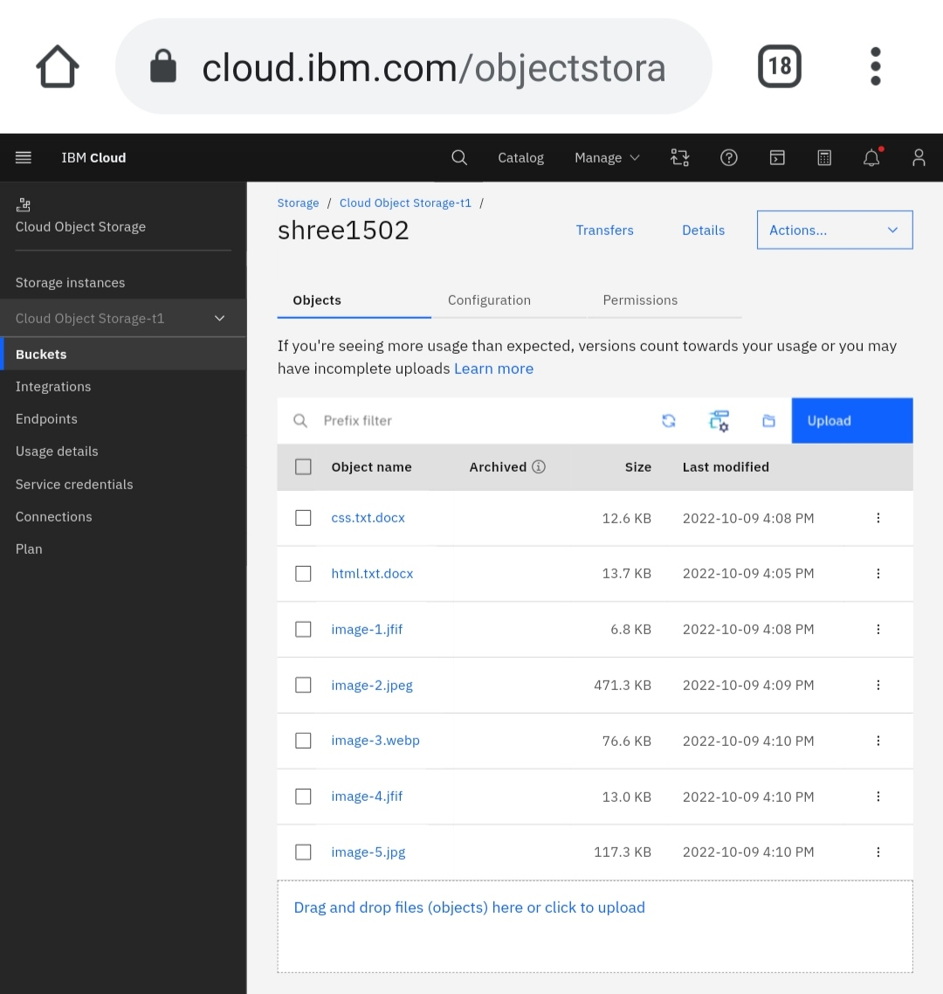

1. Design a chatbot using IBM Watson assistant for hospital.

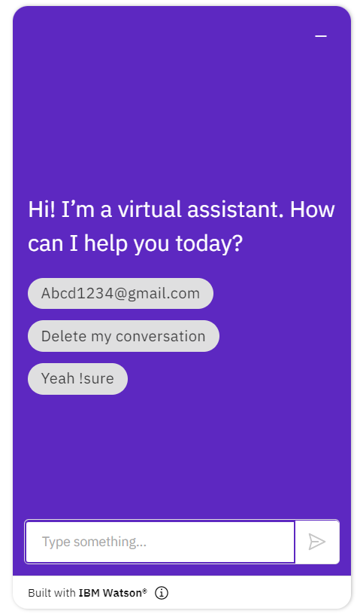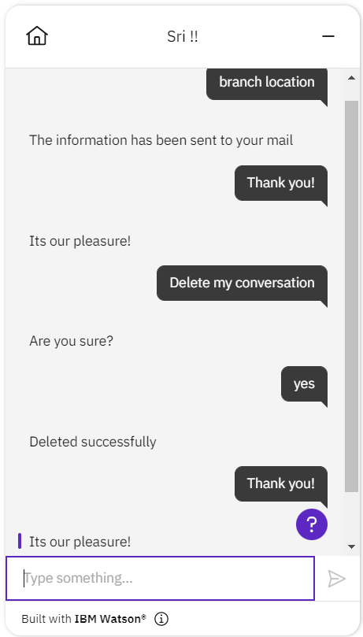

1. Create Watson assistant service with 10 steps and 3 conditions. Load that script in HTML page.

bot.ht

<!DOCTYPE html>

<html>

<head>

</head>

<body>

<script>

window.watsonAssistantChatOptions = {

integrationID: "2f6dfad5-1bf0-422c-be46-e4cbd0f16581", // The ID of this integration.

region: "au-syd", // The region your integration is hosted in.

serviceInstanceID: "4eb1772c-e2f3-4816-9d30-708b9975768c", // The ID of your service instance.

onLoad: function(instance) { instance.render(); }

};

setTimeout(function(){

const t=document.createElement('script');

t.src="https://web-chat.global.assistant.watson.appdomain.cloud/versions/" + (window.watsonAssistantChatOptions.clientVersion || 'latest') + "/WatsonAssistantChatEntry.js";

document.head.appendChild(t);

});

</script>

</body>

</html>